**Ben Lowell 2025**

**Competitor Welcome Packet**

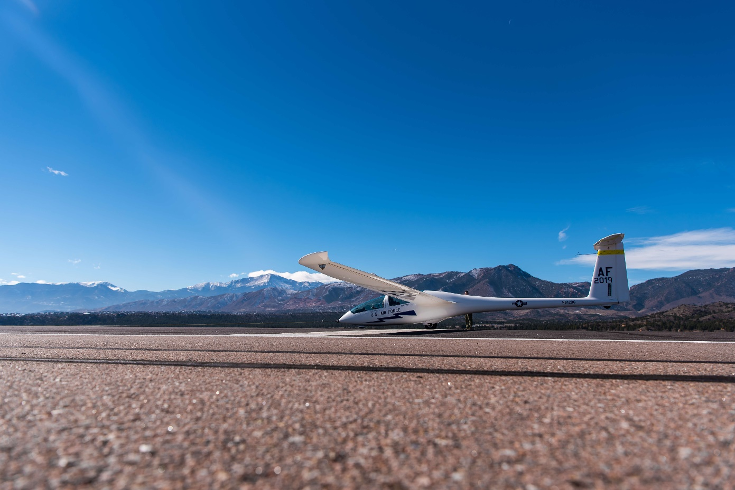

**U.S.A.F. Academy Airfield (KAFF)**

**24-27 April 2025**

**Welcome!**

Thank you for pre-registering. IAC Chapter 12 is excited to host 2025’s Ben Lowell Aerial Confrontation in conjunction with the U.S. Air Force Academy!

As you are aware, this contest has additional registration requirements to gain permission to land at the USAFA Airfield and to gain access onto the installation. There are a handful of forms to fill out and some deadlines to be aware of. I’ve compiled a checklist, the forms, and instructions into this packet for your convenience.

Additionally, we have a non-standard arrival procedure for those flying in. USAFA flying ops will be occurring during the arrival. This procedure will help our controllers, pilots, and you stay safe and separated. The arrival is no Oshkosh, but I ask that you familiarize yourself with the attached procedure. Please have a hardcopy of the kneeboard onboard your aircraft prior to arrival. I’m happy to send you a printed hardcopy if you do not have access to a color printer.

The contest schedule and lodging information is also attached. This packet should contain the information needed, but if you have any questions, suggestions, or requests, please feel free to contact me via text, email, or phone call at any time.

Thank you in advance for your time, patience, and enthusiasm to safely execute this year’s contest!

Respectfully,

*Michael Laub, IAC #442371*

*Contest Director, Ben Lowell ‘25*

*Cell Phone: 1-440-452-0707*

*Michael.Laub.1@us.af.mil*

**Competitor Checklist:**

**□ DD Form 2400 –** Complete by **Feb 24th, 2025**

*This form verifies your insurance coverage.*

* Every PIC needs to complete this form. One form required per aircraft.

Non-PIC competitors sharing aircraft while flying with an insured PIC do not need to complete this form.

* Send to your insurance company for them to fill out boxes 1 - 9.
* Send to [Brandon.mills.1@us.af.mil](mailto:Brandon.mills.1@us.af.mil), **NOT** the email on the form.

□ **DD Form 2401 –** Complete by **Feb 24th, 2025**

*This form allows us to approve you to operate at KAFF.*

* Every PIC needs to complete this form. One form required per aircraft.

Non-PIC competitors sharing aircraft while flying with an insured PIC do not need to complete this form.

* Complete boxes 1 – 6 only.
* Send to [Brandon.mills.1@us.af.mil](mailto:Michael.Laub.1@us.af.mil), **NOT** the email on the form.

□ **DD Form 2402 –** Complete by **Feb 24th, 2025**

*This is the hold harmless agreement required to be signed by all pilots.*

* One form required per competitor.

Every competitor, including those competitors sharing aircraft, should each complete this form.

* Complete boxes 2 & 3. Most competitors will only need to complete 2(b).
* Send to [Brandon.mills.1@us.af.mil](mailto:Michael.Laub.1@us.af.mil), **NOT** the email on the form.

**□ Installation Access Form –** Complete by **March 20th, 2025**

**□ Review Airfield Info and Print KAFF Arrival Kneeboard**

*Contact CD to request a printed, mailed copy of the kneeboard.*

**□ IAC Competitor Checklist**

* Proof of Insurance
* Current Medical
* Pilot’s Certificate
* Driver’s License
* Parachute
* Checkbook / Cash
* Proof of Annual Insp
* AROW Documents
* IAC Member Card

**KAFF Airfield Information:**

**NOTE: AIRPORT IS PRIVATE USE. PERMISSION REQUIRED PRIOR TO LANDING. AIRCRAFT WITHOUT APPROVAL WILL BE DENIED ENTRY.**

**KAFF IS NOT LIGHTED. OPERATIONS ARE NOT APPROVED AFTER SUNSET.**

**CHECK LATEST NOTAMS BEFORE DEPARTURE. NOTAMS PUBLISHED AT: NOTAMS.FAA.GOV**

**KAFF RUNWAY INFO**

**Runway 16R / 34L:** 4,500’ x 40’

**Runway 16C / 34C:** 4,500’ x 75’

**Runway 16L / 34R:** 3,500’ x 75’

**Runway 08 / 26:** 2,510’ x 75’

**KAFF OVERVIEW**

**Elevation: 6,576’ MSL**

**Time Zone: UTC -6 hrs**

**Tower Active SR / 0645L**

**(whichever is later) to 2000L.**

**FREQUENCIES**

**KAFF ATIS: 128.525**

**Academy Tower: 124.150**

**Skytrain: 127.150**

**Academy Ground: 118.125**

***CTAF: 124.150***

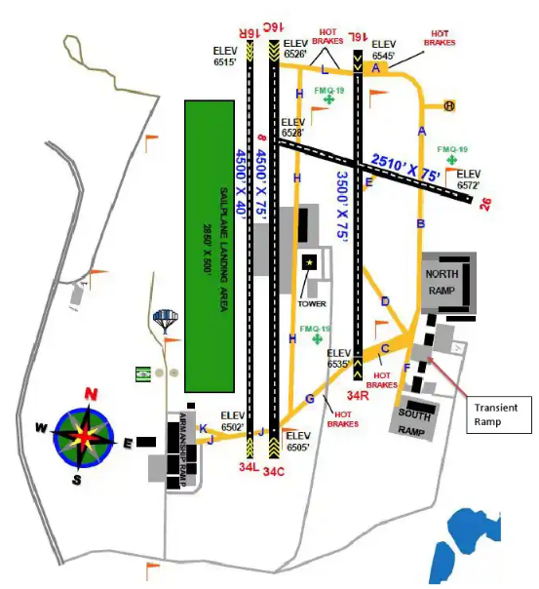

* CAUTION: UAS OPERATIONS 3-6 NM NW SFC-8500 FT MSL OVER USAF ACADEMY PROPERTY.
* CAUTION: NUMEROUS NON-STANDARD MARKINGS EXIST ON AIRFIELD.
* CAUTION: CEILING MAY BE LOWER TO N, E, AND W DUE TO RISING TERRAIN.
* CAUTION: MULTIPLE CRANES WITHIN 3 NMR OF KAFF IN NE QUADRANT UP TO 250 FT AGL.
* CAUTION: HIGH WIND ALERT SYSTEM N OF RUNWAY 08/26 AND E OF TXIWAY A UNLIGHTED.
* HIGH DENSITY VFR TRAINING, GLIDER TRAINING, AND PARACHUTE OPS SFC-17500 FT MSL WITHIN 5NM.
* SEE SPECIAL NOTICE US AIR FORCE ACADEMY VOLUME FLIGHT TRAINING AREAS FOR ADD’L INFO.
* CLASS D ATC SERVICES AVAILABLE DURING AIRFIELD OPERATING HOURS.
* AERODROME RUNWAY CC NOT REPORTED.

**REFERENCE ONLY – NOT FOR NAVIGATION**

**COMPETITOR PARKING**

**KAFF ARRIVAL KNEEBOARD**

* Tune **KAFF ATIS** (128.525)
* Contact **“Academy Tower”** (124.150) when 10 miles out with **type, call sign, & “inbound for aerobatic competition”**
* Tower may ask for your landing permit number.

Your Permit Number: ________________

* Expect Academy Tower to direct you to hold in an orbit at **‘Brunswick’** or **‘Chapel’** at 8,400’ MSL:

**Brunswick:** Northeast of the intersection between Interquest Pkwy and I-25, just west of a large blue church.

***Orbit Coordinates: N 38.9928° W -104.8114°***

**Chapel:** Over the Chapel Hills Mall, east of I-25, southwest of the solar panel facility. Remain clear of the COS Class-C Airspace.

***Orbit Coordinates: N 38.9476° W -104.7954°***

**For both holds:**

* Remain East of I-25 until receiving landing clearance / further guidance from Academy Tower.

Reference KAFF Airport Diagram for taxi guidance. Parking is on the ramp just west of the control tower.

**USE CAUTION FOR USAFA AIRCRAFT RECOVERING INTO KAFF AND OTHER ARRIVING COMPETITORS. USAFA AIRMANSHIP OPERATIONS WILL BE ACTIVE DURING PORTIONS OF THE ARRIVAL.**

**BLUE CHURCH**

**Brunswick Orbit – 8,400’ MSL**

**INTERQUEST PKWY**

**INTERSTATE 25**

**SOLAR PANELS**

**Chapel Orbit – 8,400’ MSL**

**KAFF AIRFIELD DIAGRAM**

**COMPETITOR PARKING**

**Tentative Contest Schedule:**

**Thursday, April 24th:**

**0900-SS:** Competitor Arrivals

**Friday, April 25th:**

**0700 – 2000:** Competitor Arrivals

**1200 – 1900:** Official Practice Time (10 min box times)

**Saturday, April 26th:**

**0700:** Mandatory Competitor Briefing at KAFF Hangar

**0730 – 1115:** Contest Flying (Categories & Times TBD)

**1115 – 1200:** Lunch Break (meal provided by IAC Ch 12)

**1200 – 1830:** Contest Flying (Categories & Times TBD)

**1830 – 1930:** Flight Awards & Pizza Social at KAFF Hangar

**Sunday, April 27th:**

**0700:** Mandatory Competitor Briefing at KAFF Hangar

**0730 – 1115:** Contest Flying (Categories & Times TBD)

**1115 – 1200:** Lunch Break (meal provided by IAC Ch 12)

**1200 – 1630:** Contest Flying (Categories & Times TBD)

**1630 – 1700:** Presentation of Awards

**1700:** Competitors Depart KAFF

**Lodging and Transportation Info:**

**Lodging:**

Reference the Contest Info page on the IAC website for latest block reservations and hotel recommendations. These hotels are within walking distance of several restaurants, a Walmart, and the pick-up area.

**Transportation:**

The Air Force Academy is an active military installation. All attendees must complete the *Installation Access Form*. Please have a valid form of government-issued ID on your person. IDs will be checked when entering the installation.

**Ubers and Taxis do not have access onto the installation.**

The airfield is not within walking distance of any hotels.

A limited number of seats will be available in vans driven by volunteers.

Pick-up will occur in the south parking lot of *The Academy Hotel* (8110 N Academy Blvd) which is within walking distance from several other hotels. Pick-up times will be provided at a later date.

Competitors who choose to lodge beyond walking distance to the pick-up area are responsible for their own transportation.

Personally-owned-vehicles are permitted and encouraged!

**If you can help provide transportation to other competitors, please let the Contest Director know so that you can be added to a rideshare document. Thank you!**